HR ANALYTICS REPORT

HR analytics, also referred to as people analytics, workforce analytics, or talent analytics, involves gathering together, analyzing, and reporting HR data. It enables your organization to measure the impact of a range of HR metrics on overall business performance and make decisions based on data. In other words, HR analytics is a data-driven approach toward Human Resources Management.

**Analytical Demand of HR team of Atliq company:**

1) working preference of people (work from home or work from office)

2) find sick leave pattern how they are taking sick leaves to draw connection for disease pattern per season for taking precautions, sanitization etc.

3) on which weekdays people are more taking WFH or sick leave or presence is high

4) **WFH Pattern:**

By knowing these we can arrange accordingly less space in the office. That will reduce our total cost(electricity, water etc), and people will be fine to work from home [ win- win situation]

5) **SL Pattern**:

* By knowing this we can understand in which month peolpe are getting sick, so we can take precautions beforehand for them like sanitization and extra care for hygiene.
* we can get to know on which day of week mostly people are taking their leave then on that day important meetings should not be arranged due to low present percentage probability.

6) **Present percentage**:

* On which month the present percentage is the most then that month would be the most productive month of the year and we can increase our workload.
* The same thing applies for the week also.
* In the festive seasons like Diwali in India the present percentage gets lower so we can easily conclude certain delay in our work
* By knowing on which particular day we see drop in present percentage we can postpone our important meetings later on.
* The employee whose present percentage is good like 100% , should get acknowledged and rewarded.

**OBSERVATIONS:**

1. **Decrease in Presence percentage:**

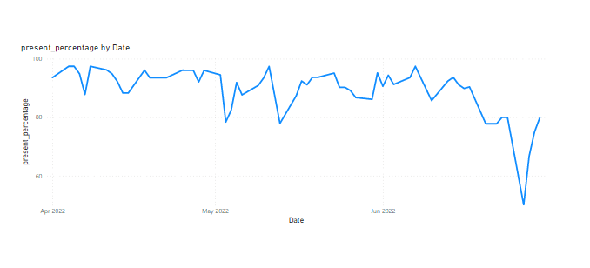

The presence percentage is gradually declining from April to June month

1. **Increase in WFH percentage:**

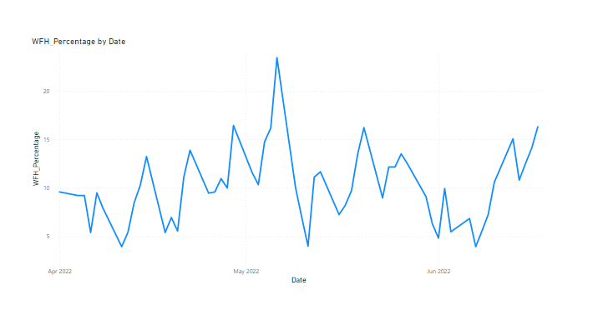

Here one uptrend of Work from Home is increased from April to June

1. **Increase in Sick Leave percentage:**

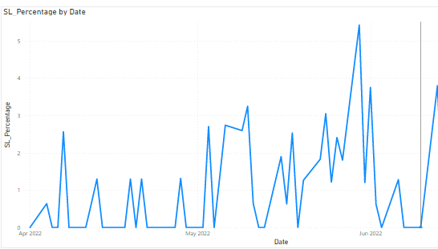

Uptrend in sick leave percentage is visible over the months.

CONCLUSION:

From here easily we can see there is a correlation between the presence percentage, WFH percentage and Sick leave percentage. The presence percentage is

Decreasing over the month and WFH and SL are increasing. That indicates that

* May be in this season people are getting sick, so better health care is needed.
* Regular health check ups and sanitization inside office needs to be done
* Proper hygiene should be maintained and necessary precautions to be taken
* If people are more interested to work from home then we can reduce our utility cost of office like water supply, electricity cost accordingly.
* The months when people are not present that much maybe we can cut some workload
* The months when people are more present we can increase work load.